Home › Tours › 8 Days Cairo, Aswan - Nile Cruise – Luxor
8 Days / 7 Nights
Cairo, Aswan - Nile Cruise – Luxor
📅8 Days / 7 Nights
👥100% Private
📍Cairo + Aswan + Nile Cruise + Luxor
🎓Egyptologist Guide
✈️Pickup: Cairo or Hurghada
Accomodation: 5 star hotels.

OverviewHighlightsItineraryAccommodationInclusions
Request a Quote
From $2,950
✓ Private Tour ✓ Per Person
Explore the Best of Egypt on an 8 Day Egypt Tour Package, giving you the best of Cairo, Aswan, and a 3-night Nile cruise. Explore the Giza Pyramids, GEM, Philae Temple, and the temples of Kom Ombo, Edfu, and Luxor with an Egyptologist guide leading every step.
We handle airport meet & assist, visa, flights, transfers, hotels, cruise, entrance fees, and a private guide who knows how to make Egypt easy for our groups. Relax, sail the Nile, and let us coordinate the logistics so you can focus on the monuments and the stories behind them.
Tour At a Glance
Detail
Duration | 8 Days / 7 Nights
Tour Type | 100% Private — your group only
Guide | Licensed Egyptologist (English)
Pickup | Cairo International Airport or Hurghada
Destinations | Cairo (3 nights) → Aswan (1 night) → Nile Cruise (3 nights)
Flights: | Domestic flights included
Entry Visa | Included
Meals | Cairo & Aswan: Breakfast & lunch daily  Cruise (3 nights): All meals — open buffet (15 meals total).
Price from | $2,950 / person (double occupancy)
Your Route
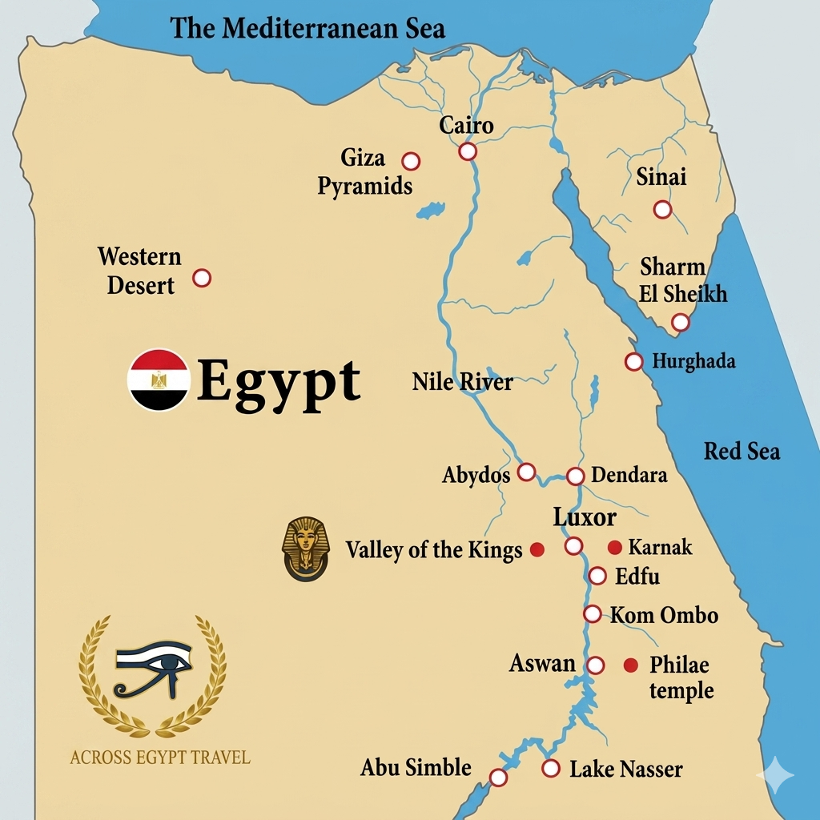
Highlights
🏛️Giza Pyramids & TheSphinx
🏺Grand Egyptian Museum (GEM)
🕌Saladin Citadel&Mohammed Ali Mosque
⛪Ancient Churches of Coptic Cairo
🏛️National Museum of Egyptian Civilization (NMEC)
🚤Philae Temple
🛡️The High Dam
The Unfinished Obelisk
🐊Kom Ombo Temple
🦅Edfu Temple
🏟️Karnak Temples Complex
Luxor Temple & The Sphinx Avenue
✦ lit up at night
👑 The Valley of the Kings (4 tombs)
🏺Hatshepsut Temple
🧑‍🎨Deir el-Medina (Artisans' Village)
🗿Colossi of Memnon
⛵Felucca Ride on the Nile

Optional Add-Ons
✨Sound & Light show at thePyramids
🎈Hot air balloon overLuxorat sunrise
✨Sound & Light Show at Karnak Temples
🏜️Abu Simble day trip from Aswan (if time allows)

Day-by-Day Itinerary
Day 1
Cairo
Arrival & Welcome
Upon your arrival at Cairo International Airport, a dedicated representative will be waiting to greet you and facilitate a seamless, private transfer to your five-star hotel. Following check-in, you will meet your private Egyptologist for a personalized orientation. This session provides an overview of your upcoming itinerary, helpful local insights, and an opportunity to address any questions. The remainder of the day is yours to relax and enjoy dinner at your leisure within the hotel.

Day 2
Cairo — Pharaonic
Giza Pyramids, Sphinx & GEM
We begin the day with an early departure to the Giza Plateau, allowing you to experience these iconic landmarks before the peak crowds arrive. Your expert Egyptologist will provide deep historical context, moving beyond the surface to explore the purpose and cultural significance of these architectural marvels through stories rarely captured by standard audio guides. Following a curated lunch, we will proceed to the newly opened Grand Egyptian Museum (GEM) for an immersive tour of the complete Tutankhamun collection. Overnight in Cairo.

Day 3
Cairo — Islamic, Coptic & Museum
Citadel, Coptic Cairo & NMEC
Your day begins with a visit to the Saladin Citadel and the exquisite Mosque of Muhammad Ali, where you will enjoy the most panoramic view of Cairo available within the city. We then proceed to explore the ancient, storied streets of Coptic Cairo, home to one of the oldest Christian communities in the world. Following a curated lunch, we will visit the National Museum of Egyptian Civilization (NMEC); final home of the most famous royal mummies. In the afternoon, you will be transferred to Cairo airport for your flight to Aswan (90 minutes flight) where you will check into your hotel to rest and prepare for the adventures awaiting you the following day. Overnight in Aswan.

Day 4
Aswan
Philae, High Dam & Nile Cruise Boarding
Check out of the hotel, you will embark on a memorable excursion with your tour guide to the breathtaking Philae Temple, a stunning island sanctuary dedicated to the goddess Isis that you will reach via a scenic private boat ride. After immersing yourself in the magic of this ancient wonder, you will visit the impressive Aswan High Dam and the fascinating Unfinished Obelisk. Board your Nile cruise before lunch. Enjoy dinner and your first evening on the river. Overnight in Aswan.

Day 5
Nile Cruise
Felucca Ride & Kom Ombo (add-on Abu Simble if time allows)
Join your private Egyptologist for a scenic felucca ride around the ancient Elephantine Island. Afternoon: Head back on board for lunch as the cruise begins sailing down the Nile. Relax on deck until we dock at Kom Ombo, where you'll take a short walk to explore the unique Kom Ombo dual Temple with your guide. Evening: Continue sailing north to Edfu, where the ship docks overnight.

Day 6
Nile Cruise
Edfu – Esna Lock – Karnak & Luxor Temples.
An early morning departure brings you and your Egyptologist guide to a waiting horse carriage (or private car), bound for the legendary Edfu Temple. Widely considered Egypt’s most spectacular and intact ancient sanctuary, its soaring architecture and deeply carved relief walls bring the myth of Horus to life in vivid detail.
Back on board, the cruise sails smoothly down the Nile, offering front-row seats to a timeless landscape of riverside villages, roaming farm animals, and swaying palms. The journey pauses for a fascinating crossing through the Esna Lock before continuing its scenic route to Luxor. Upon arrival, step ashore with your guide to witness the staggering scale of the Karnak Temple Complex—a world-class archaeological treasure tracing 2,000 years of royal history. As the sun sets, visit the magnificent Luxor Temple and stroll down the legendary Avenue of Sphinxes. Experiencing these monuments illuminated against the night sky offers a completely different, awe-inspiring atmosphere than a daytime visit. Overnight in Luxor.

Day 7
Luxor — West Bank Tour – Fly to Cairo
Valley of the Kings, Hatshepsut , The Artisans’ Village

Check out of the cruise, Then head to the west bank of the Nile, enjoy a comprehensive exploration of the West Bank, beginning with the Valley of the Kings, where you will visit three significant tombs, plus the extraordinary tomb of Ramesses V and VI. Your tour continues with visits to the Temple of Hatshepsut, the remarkable Artisans' Village (Deir el-Medina), and the towering Colossi of Memnon. A curated lunch is included at a highly-rated local restaurant during your day of discovery. . Finally, you will be comfortably transferred to Luxor Airport to catch your flight back to Cairo (an hour flight) where our representatives will pick you up and transfer you to your airport hotel; check in and enjoy a peaceful night sleep.

Day 8
Cairo
Final Departure
Our company representative will meet you at your hotel to transfer you to the departure terminal, providing full luggage assistance until you are safely checked in at the airline desk.

Accommodation
Two accommodation tiers are available. Both are premium 5 star properties in the best locations. Upgrade at booking.
⭐ Standard (Included)
Cairo
★★★★★
Pyramids-view 5-star property — Steigenberger Pyramids or similar. 3 nights.
Aswan
★★★★★
Sonesta Nouba Aswan — Nile-view room, 1 night.
Nile Cruise
★★★★★
3 nights on MS/Amwaj Livingstone or similar. Nile-view cabin.

✦ Premium Upgrade
Cairo
★★★★★
Four Seasons Cairo at Nile Plaza or Marriott Mena House. 3 nights.
Aswan
★★★★★
Sofitel Legend Old Cataract or similar. 1 night.
Nile Cruise
★★★★★
Ms. Mayfair, Ms. My Flower, or similar. 3 nights.
💡 All rooms are private. Single supplement available. Family rooms available for groups with children. Ask us for current availability and upgrade pricing.
Inclusions
What is included in the tour
- Airport meet & assist by your dedicated representative
- Entry visa to Egypt
- Domestic flights (Cairo → Aswan and Luxor → Cairo)
- All airport & inter-city transfers by private air-conditioned vehicles
- 3 nights 5-star hotel in Cairo
- 1 night 5-star hotel in Aswan
- 3 nights 5-star cruise accommodation on the Nile
- Cairo & Aswan: Breakfast & lunch daily
- Cruise (3 nights): All meals — open buffet (breakfast, lunch & dinner)
- All entrance fees to listed sites
- Private Egyptologist guide (English — other languages on request)
- Complimentary bottled water and snacks during excursions
- All taxes and service charges
What is NOT included in the tour
- International airfare
- Drinks (water is provided during tours)
- Gratuities for guides and drivers
- Personal expenses — phone calls, laundry, souvenirs, etc.
Pricing
Category | Price Per Person
Standard (double occupancy) | From $2,950
Single supplement | +50% of base price
Group of 4–7 travelers | 10% discount applied
Group of 8+ travelers | 15% discount or bonus inclusions
All prices are quoted in USD.

Children's Policy
Age | Price
Under 5 years | Free (max 1 child per booking)
Ages 5–11 | 50% of adult price
Ages 12 and over | Adult fare
Cancellation Policy
25% non-refundable deposit.
60—31 days prior to arrival: 50% penalty
30-16 prior to arrival: 75% penalty
15 days and less prior to arrival: 100% penalty.

